CHANCERY SQUARE HOMEOWNERS ASSOCIATION
ACC STANDARDS

Color Schemes (Paint)
1. The following paint color groupings are part of the registration of the community with the City of Fairfax and may not be deviated from.
2. The colors on siding, trim, garage doors, shutter, front doors, etc., are all McCormick Paint colors. Care should be given when using the same names with other paint companies to ensure a match to the referenced McCormick colors.
3. Repainting or staining to match its original color need not be submitted for ACC approval.
4. All references to paint colors herein are given as McCormick latex exterior paint.
5. The following paint color schemes are based on house model groupings:
Group 1: See model design of 10516 James Wren Way  Siding: Desert Sand  Brick: Rictex 555  Door: Foxhall Green  Shutters: Foxhall Green  Trim: Amber White  Roof: Moire’ Black | 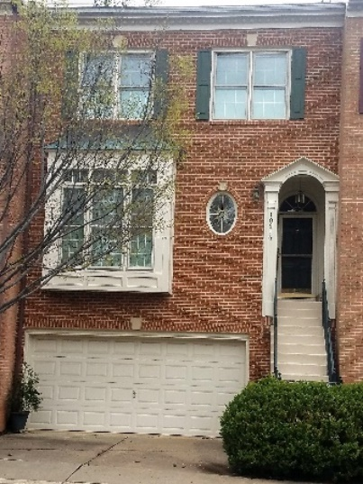
Group 2: See model design of 10537 James Wren Way  Siding: White  Brick: General Shale Shenandoah Colonial  (a Medium Red)  Door: Farmhouse Red  Shutters: Farmhouse Red  Trim: Marble Ice  Roof: Moire’ Black | 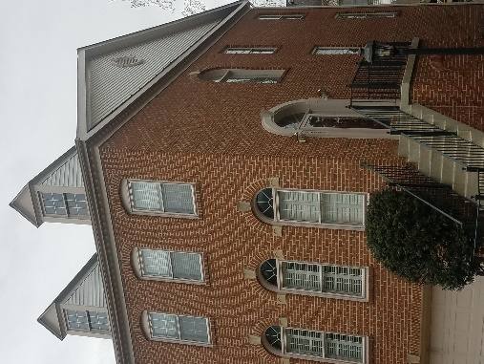

Group 3: See model design of 10538 James Wren Way  Siding: Desert Sand  Brick: Montpelier Flash Range Colonial  Door: Carolina Slate  Shutters: Carolina Slate  Trim: Newport  Roof: Moire’ Black7 | 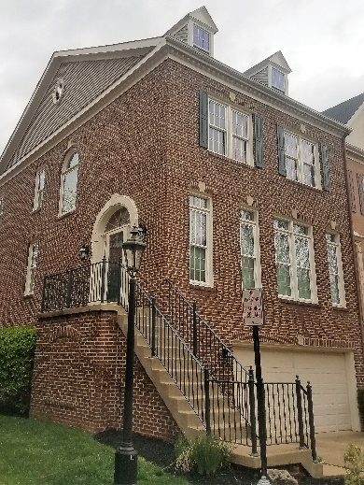
Group 4: See model design of 10532 James Wren Way  Siding: White  Brick: Rictex 551  Door: Georgetown Green  Shutters: Georgetown Green  Trim: Incense  Roof: Moire’ Black | 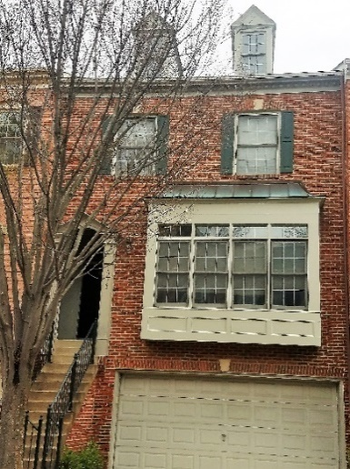
Group 5: See model design of 10536 James Wren Way  Siding: Cameo  Brick: Rictex 380  Door: Old Colonial Red  Shutters: Old Colonial Red  Trim: Greystone  Roof: Moire’ Black | 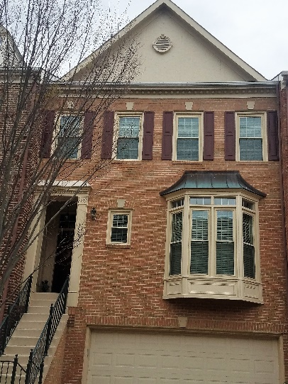

Group 6:See model design of 10535 James Wren Way  Siding: Cameo  Brick: Rictex 382 (a pinkish tan)  Door: Old Carriage Brown  Shutters: Old Carriage Brown  Trim: Wheat  Roof: Moire’ Black | 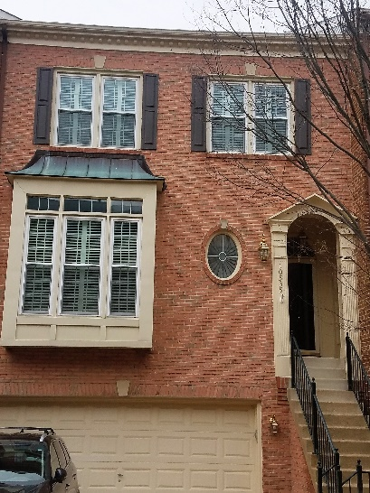
Group 7: See model design of 4192 Lord Culpeper  Siding: Desert Sand  Brick: Rictex 511  Door: Georgetown Green  Trim: Newport  Roof: Moire’ Black | 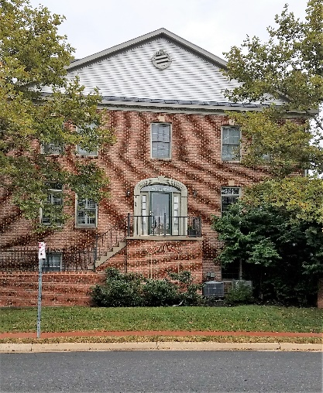

7. Front porch metal step railings: McCormick Paint-Georgetown Green
8. Roofs: Morie’ Black
9. Siding: Should match existing color.
10. Gutters: White or cream to match trim color as closely as possible.
11. Downspouts: Brown
12. Fences and Deck Rails: McCormick Brand Paint-Navajo White
13. Steps and Driveways: Please see Paragraph EE below.

July 2018

