Chancery Square Homeowner’s Association
ACC Standards

Exterior Lights

1. All exterior lights shall be maintained in operating condition. Homeowners shall replace their exterior light fixtures once they become aged and/or in tarnished condition.

2. Homeowners installing new exterior light fixtures are required to obtain ACC approval.

3. A list of ACC approved exterior light fixtures are listed in paragraph S-8 below and may also be found on the Chancery Square webpage at www.chancerysquare.net

4. All exterior light fixtures mounted to the house (i.e., front of house, rear of house, and next to garage door) shall be in the same finish and same style number.

5. All pendent lights in portico’s shall be in the same finish as the exterior mounted lights.

6. While not required, it is recommended to purchase exterior lights from vendors that are authorized dealers for Kichler Lighting and Livex Lighting to ensure warranties.

7. Homeowners are encouraged to leave exterior and porch lights on at night to enhance community security.

8. Exterior lighting shall not be directed in such a manner as to create an annoyance to the neighbors or motorists.

9. All exterior light bulbs shall be restricted to the shade of white. Colored lights re prohibited.

10. The use of motion detectors on external lights is prohibited.

11. Flood lights and/or spot lights are prohibited.

12. Approved exterior light fixtures are listed below.

MANUFACTURER | MODEL | DESCRIPTION | STYLE # | FINISH |  | WARRANTY
Kichler Lighting | Bay Shore | Front Fixture | 9713PB | LifeBrite Polished Brass |  | Lifetime
Kichler Lighting | Bay Shore | Back Fixture | 9711PB  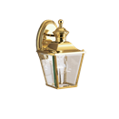 | LifeBrite Polished Brass |  | Lifetime
Livex Lighting | Georgetown | Pendant | 236-502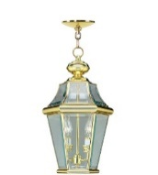 | Polished Brass |  | 1 Year
MANUFACTURER | MODEL | DESCRIPTION | STYLE # |  | FINISH | WARRANTY
Livex Lighting | Georgetown | Front Fixture | 2261-04  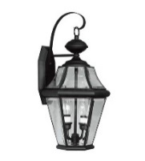 |  | Black | 1 Year
Livex Lighting | Georgetown | Back Fixture | 2061-04  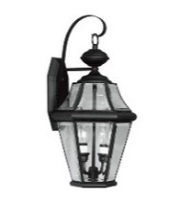 |  | Black | 1 Year
Livex Lighting | Georgetown | Pendant | 2265-04  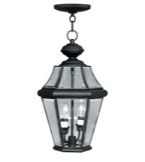 |  | Black | 1 Year
Livex Lighting | Georgetown | Pendant | 236-502 |  | Polished Brass | 1 Year

MANUFACTURER | MODEL | DESCRIPTION | STYLE # | FINISH | WARRANTY
Livex Lighting | Georgetown | Front Fixture | 2261-02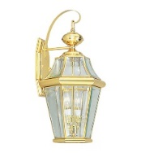 | Polished Brass | 1 Year
Livex Lighting | Georgetown | Back Fixture | 2061-02 | Polished Brass | 1 Year

Lighting (Exterior), New Fixtures Replacement

When replacing existing exterior light fixtures at the same location as installed by the builder, uniformity shall be maintained. For example:

- An end-unit house with twin exterior light fixtures at the front entrance,
and existing exterior light at the garage, all three exterior lights shall be replaced at the same time, in the same style and finish, for uniformity.

- An interior-unit house, with an exterior light fixture installed on the brick,
hanging light in the portico, and existing exterior light at the garage, all three exterior lights shall be replaced at the same time, in the same style and finish, for uniformity.

(c) When replacing exterior light fixtures on the rear of a house, (the deck and patio) exterior light fixtures must be replaced at the same time, in the same style and finish, for uniformity.

2. While the front entrance and rear house exterior light fixtures are not required to be replaced simultaneously, unless desired by the home owner, when they are replaced, the policy above shall apply. The objective of this policy is to ensure that all exterior light fixtures on any given side of a house are in harmony for a complete and uniform appearance on an individual house.

Light (Exterior) Fixtures Modification/Placement:

1. Exterior Garage Lights: Homeowners wishing to add a light fixture next to their garage are required to submit an “Application for Exterior Modification” to the
ACC Committee for approval prior to beginning any work. If approval is granted, the installation of a matching exterior light (see specifics above) will be authorized with placement on the brick wall next to the garage. The fixture shall be positioned on the side of the garage closest to the exterior steps. For end units: The top of the fixture shall be approximately 4 inches from the top metal frame of the garage opening and shall not extend more than 13 inches from the metal side opening of the garage. For interior units: The top of the fixture shall be approximately 4 inches from the top metal frame of the garage opening and centered on the brick space. Installation shall be performed by a licensed
electrician and as required by the Virginia Uniform Building Code, the homeowner/contractor shall obtain an electrical work permit and final inspection from the City of Fairfax.

2. The installation of any other new exterior light fixture in a location other than the original location as installed by the builder and where alterations to the original electrical wiring is made, shall (i) be approved by the ACC; (ii) be installed by a licensed electrician and (iii) as required by the Virginia Uniform Building Code, the homeowner/contractor shall obtain an electrical work permit and final inspection from the City of Fairfax. This shall apply to all exterior areas of the house, including the front, garage, side, patio and deck areas of a house.

March 2024

